Pakenham Pastoral Charge
St. Andrew’s and Zion United Churches
2015 - 16
Strategic Planning Steering Committee
Final Report
October 26, 2016
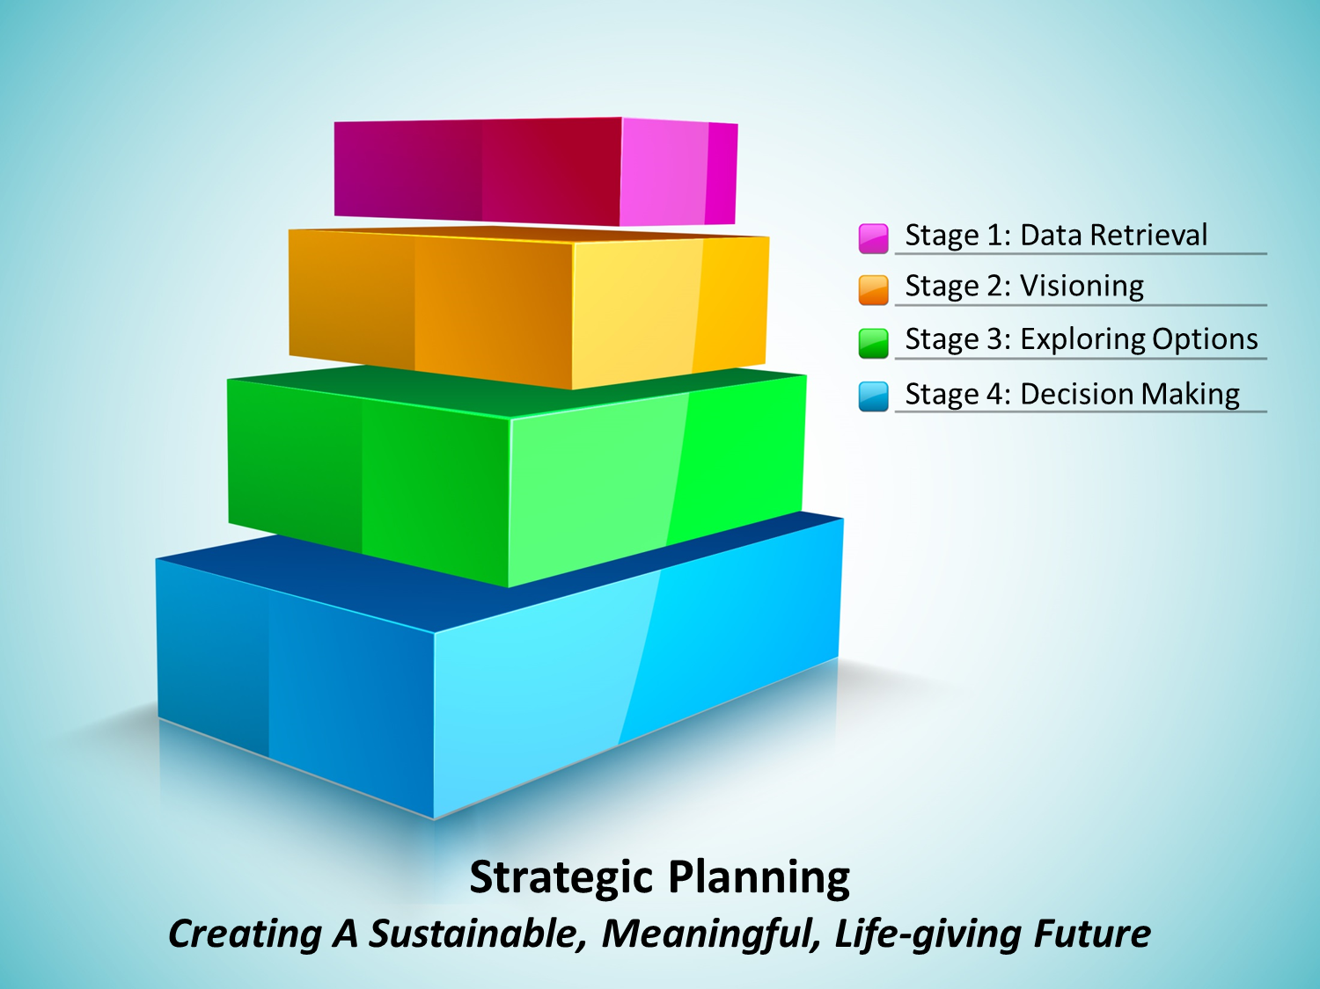
2015 – 16 Pakenham Pastoral Charge
Strategic Planning Steering Committee
Purpose of this Project
To enable the Pakenham Pastoral Charge, (Zion United, Cedar Hill and St. Andrew’s United, Pakenham, to make wise choices about their future in the hopes of extending a sustainable and thriving ministry well into the future..
Outline
Our Pastoral Charge has an amazing history. We have nurtured community, helped meet personal needs from a Christian perspective, and we have provided leadership in music, community development and Christian witness. We can be justly proud of our accomplishments and how we have continued to do so even in trying times. Indeed our success has in part been the result of our ability to adapt to changing conditions. Recent declines in volunteer participation and finances suggest the need for significant changes now. In addition to changing the ministry we finance, we also need to care for the dedicated core who live out their call to respond to the needs within and beyond our Church.
This report summarizes the process we have been through in the past year and offers eight recommendations. No matter what decisions are made now, we will need to continue to reflect on the needs around us and our abilities to meet them as we make further adjustments within our emerging reality. We will struggle, as those before us struggled, to know what is best. May we be sensitive to the guidance we receive, be wise in our responses, and be courageous in the midst of many uncertain factors.
- Summary or Highlights from the Statistical Report
  - Insights common to both Churches:
    - Our top givers provide a disproportional amount of our overall revenue.
    - As few as 10 contributors provide as much as 40% of our annual givings.
    - In most cases these are elderly contributors and their gifts will not easily be replaced.
    - Capital and Operating costs are increasing; at times significantly so.
    - Now, more people do not attend yet contribute, than do attend and contribute.
    - Retirees, (our primary volunteers and financial supporters), especially after 80 leave our community (through residential moves or death)
    - Church participation has declined; participant’s increased ages suggest an accelerated decline.
  - St. Andrews
    - for the first time in 10 years givings are down for the first 9 months of 2016
    - number of givers are down at St. Andrew’s
  - Zion
    - number of givers are basically being maintained as are contributions
- Highlights of the Focus Group Work and General Feedback
  - St. Andrews
    - There was the stated priority that we maintain the building.
    - That we insure we provide Sunday Services, meet requests for Funerals, Weddings & Baptisms and that we provide outreach to our community.
    - While most support the current music program, some feel cuts possible.
    - There was a variety of opinion on reducing the minister to part-time.
  - Zion
    - Appreciation for the church community which should be maintained.
    - Priority should be Sunday Services and Funerals, Weddings & Baptisms.
    - The building should be maintained at its current level.
    - Some felt we need to reconsider where our fundraising dollars are spent.
    - Some felt we need to increase communication in and beyond our church.
    - There was openness to reduce to less than a full-time minister.
- Summary of Action Taken So Far (By the Official Board)
    - Established a ‘Formula Committee’ to develop a mathematical formula (that is fair and adjusts as we evolve) to determine the annual financial contribution of each Congregation to the Pastoral Charge.
    - Reduced the Official Board’s bank balance (money on hand).
    - Promoted an ‘Every Family’ visitation; St. Andrew’s plans to do it.
    - Through M&P Comm., approved guidelines ‘Priorities for our Minister’.
    - Reached out to St. Marks, St Peter Celestine and local United Churches.
    - Declared an effort to ensure we have balanced budgets by 2018.
- Financial Requirements, Insights and Implications
Appendix A outlines our financial realities and related projections and shows we need to adjust our expenditures immediately. Failing to do so will compound the negative impact on our congregations and in the near future produce more dire choices that will have a depressive impact on our life and work.
To meet this need we recommend reducing our minister to a ¾ time position. This will enable us to move toward balancing our budgets and shift our primary focus from finances to ministry possibilities. The M&P Committee in consultation with Jeff has created a blueprint for the year that should reduce the impact. The impact should not be all that significant for church supporters. Fifty years ago our minister served three churches with 300 supporters, while today our minister serves two churches with 100 supporters. The main means by which the minister’s time will be reduced is by working one less day per week. Most parishioners will not even notice the change. Future ministry focus will be Sunday Services, Rites of Passage and Pastoral Care and reduced effort on outreach and administration.
The most important factors in such a change are: our attitude as church leaders and the fact that balanced budgets lead to sustainability. Worship services, rites of passage and visitation are our central purpose even as community outreach is reduced. If we reduce the time the minister spends on administration and at the same time develop possibilities around shared ministry, the anticipated impact on community outreach may be significantly reversed. Being committed to balanced budgets, while we seek financial support, will guarantee our future existence. Failing in this commitment will likely reduce the trust people have, not only in the viability of our ministry, but even in the certainty of our future.
Maintaining our ministry and our churches will require adjustments. Both churches recognize we need to maintain our buildings. Part-time ministry will require a reduction in our expectations of the minister. It may be valuable to streamline our governance; explore ways to share ministry tasks with neighbouring churches (Instead of preparing material used only once, exchanging ministers could remove almost half of the preparation time);explore how we might expand the use of our buildings (leasing possibilities, invest in them so they are more attractive rental space); and other ideas could enable our buildings to be more self-sufficient so that we could use our revenue for ministry.
- Moving Into Our Future
    - Sunday morning is fundamental to who we are. We need to eagerly nurture our understandings and relationship with God and how we each seek to discern how we should respond to that call.
    - Respond positively to requests for rites of passage from those connected to the Church and insure we do these events well.
    - Our identity is tied to our buildings. At this point in our history, it is essential to care for our buildings.
    - Our future depends on involvement. Incorporating more people into the life and work of our churches is vital.
    - Streamline administration and increase short-term volunteering will help.
    - Communicate with other local churches and neighbouring United Churches so as to share resources and reduce ministry expenses. This may not produce immediate benefits, but will help create a climate so that in the future we may entertain more significant ideas.
    - Most church volunteers are in the 50-75 age range (empty nesters to the early retirees). The 50-65 group are not being replaced sufficiently to replenish those who are aging. We need to focus on this demographic.
    - An opportunity for growth would be to reach out to those who do not attend but continue to contribute.
- Concluding Statements
    - We believe this report to the Official Board should be shared with the Congregations for their information and approval.
    - The recommendation to move to ¾ time position is a ‘change in the terms of an ongoing pastoral relations’. The procedures established for such a change will need to be followed by the Official Board including proper notice of meeting and that the section of the meeting dealing with the change be chaired by a representative of Presbytery Pastoral Relations.
    - We believe this work of strategic planning should be ongoing. Perhaps committees could be established to address growth and insure that ongoing conversations about planning occur for the Pastoral Charge.
- Recommendations
The Strategic Planning Committee recommends that:
- We move immediately (2017) to ¾ time ministry.
- Future balanced budgets are necessary.
- Memorium Funds (including Wilson Bequest) are not used for operating expenses.
- All Reserve Funds (Memorium & Surplus) not be accessed for capital improvements or extraordinary needs until sustainable budgeting is achieved.
- Insure our buildings are maintained by budgeting appropriately (annually for St. Andrew’s a minimum of $10,000 and for Zion $3,000) and any of that amount not expended be carried forward and added to the following years’ maintenance budget.
- Create Finance Committees for each Congregation whose task will be to propose balanced budgets and forecast sufficiently enough to enable the Board to make timely decisions concerning expenditures. The committee to consist of the Chair of Stewards, Clerk of Session or Chair of Worship & Life and the minister, with input from the Treasurer.
- Encourage everyone associated with the Church to use PAR.
- Begin dialogues beyond our church which consider ways in which we might reduce our ministry expenses and increase the use of our buildings.
Strategic Planning Steering Committee
Ray Giles, Denzil Ferguson, David Wilson, Jeff de Jonge
2015 – 16 Pakenham Pastoral Charge
Strategic Planning Steering Committee
Final Report – Appendix A
St. Andrew’s
Column #1 Assumes:
- maintaining current ministry;
- starting in 2017 adding revenue of $5,000 from the Manse Fund; and
- a $5,000 reduction in expenses as a result of the new sharing formula with Zion.
Column #2 Assumes:
- in addition to the assumptions of Column #1 an annual increase in expenses of 2%; and
- an annual decrease in revenue of 2% (starting in 2017)
Column #3 Assumes:
- in addition to the assumptions for Columns #1 & #2 that the Minister is reduced to ¾ time (in 2017):

2016 Expenses | $125,000
Revenue | $100,000
Deficit | -$25,000

 | Status Quo | Column #2 | Reduce Minister
2016 Deficit | -25,000 | -25,000 | -25,000
2017 Deficit | -15,000 | -19,500 | -7,500
2018 Deficit | -15,000 | -24,000 | -12,000
2019 Deficit | -15,000 | -28,500 | -16,500
2020 Deficit | -15,000 | -33,000 | -21,000
2021 Deficit | -15,000 | -37,500 | -25,500
5 yr. accumulated debt | $100,000 | -$167,500 | -$107,500
2022 Deficit | -15,000 | -42,100 | -30,100
2023 Deficit | -15,000 | -46,700 | -34,700
2024 Deficit | -15,000 | -51,300 | -39,300
2025 Deficit | -15,000 | -55,900 | -43,900
2026 Deficit | -15,000 | -60,500 | -48,500
11 yr. accumulated debt | -$175,000 | -$424,000 | -$304,000

Zion Detail | Revenue | Expenses | Surplus/Deficit
5 Yearly Average | $32,000 | $30,000
¾ Minister |  | ($6,500)
Manse Fund Interest | $1,500
Re-Assessment |  | $5,000
Annual Bldg. Mntc |  | $3,000
Annual Surplus / Deficit |  |  | $2,000

