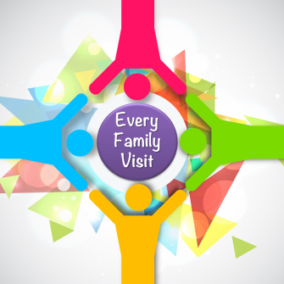 | Report to Executive Council  June 14, 2017
Every Family Visit Committee (The Committee)
Bronwen Harman, Jeff de Jonge, Marilyn Snedden, Rhonda Tees, Chair and Secretary.
Thanking Volunteers
This project would not have been possible without the volunteers who dedicated their time, leadership and expertise to this project. The Committee expresses its sincere appreciation to the teams of visitors for a job very well done.
Three Key Objectives
- The top priority for the Every Family Visit was connection. The visits were designed to connect with families and create an opportunity to ask a key open-ended question. The question was designed to help us understand what people are thinking and wanting from the church. The question was: “How are you feeling about the church?” Noting and understanding what is relevant to people will be of key importance as we continue to build for the future.
- The second objective was to share information with families about the transition that is underway and the work that has been done to date.
- The third objective was to talk about possible connections to the church through participation.
Measurable Goals
Results against the approved SMART goals are as follows:
Goals | Results To Date
- 80% of families on the target list will receive a face-to-face visit. | 69%
- 100% of families on the target list will receive a package of information | 61%
- 100% of feedback collected by visitors will be returned to the committee for analysis. | Number unavailable
- 6 new identifiable givers. (from 94 – 100) | Number to follow
- 35% of identifiable givers, including new givers, will be on Pre Authorized Remittance (PAR) at the end of the project | - Number to follow  - As a result of the visits a total of 10 families either moved to or enrolled in PAR, 3 families increased their PAR donations and 9 families gave a one-time donation.
- 10% of visits result in a one-time gift. | - 10% (Total $2,000)
Every Family Visit by the Numbers
Target | Actuals
114 Planned contacts with families.  (face to face, calls, other contact and self-administered) | 109 / 96%
- Face to face (72) | 50 / 69%
- Calls (19) | 26 / 137%
- Visitors (23) | 23 / 100%
- Other (0) | 10
- Incomplete or unreported (0) | 4
The commitment to assign no more than 6 visits to each team was kept.
Some teams were also assigned calls but no more than six per team.
Visitor Survey Results
Visitors were asked to fill out a survey about the training and visits. 14 of 23 visitors retuned their surveys. The survey results are as follows:
Training
- I found the training helpful 100% agreed or strongly agreed
- The training materials and tools were useful. 93% agreed or strongly agreed
- The training made me feel more comfortable with the visits. 85% agreed or strongly agreed
Visits
- The families were generally receptive to our visits. 85% agreed or strongly agreed
- Conducting the visits with a partner was beneficial 92% agreed or strongly agreed
- The families appreciated us connecting with them in this way 83% agreed or strongly agreed
- I’m glad I participated in this project. 93% agreed or strongly agreed
Themes, Observations and Suggestions from Visitors
- Don't assign friends and family to visitors because it makes it easier to decline a visit.
- Need clearer questions and ice-breakers that could be given beforehand, perhaps on the phone when called to make an appointment for a visit.
- Formally recognize older members who have contributed to the church for decades.
- Connect with people in this way more often and without asking for money.
- Arrange transportation for people who want to come to church but no longer drive or don’t have a car.
- There were concerns that the church is not accessible.
- Better care and recognition of volunteers.
Project Expenses
The Committee spent $68.15 on supplies for the project.
General Observations
The Committee makes the following general observations about comments, concerns and suggestions made by families during the visits.
- There is a continuum of people associated with St. Andrew’s. All of the families along this continuum support the church financially. At opposite ends of the continuum families have much different perspectives and expectations about what they want and need from the church. This continuum is depicted in Figure 1 below.
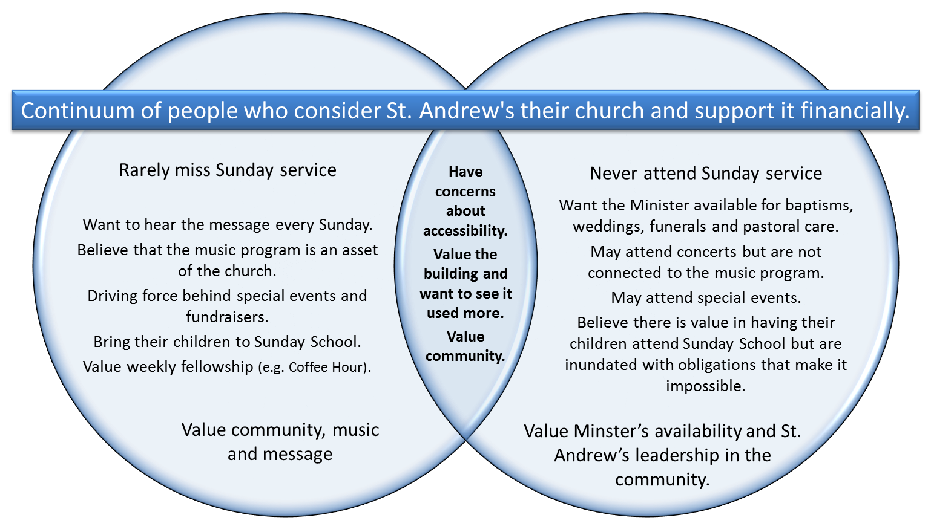
- People want the church and building to be here for the long run.
- People want the building to be used more extensively for our own purposes as well as for the community.
- We need to continue communicating information about our finances to help people understand where our money comes from and what it is used for.
- People feel we need a focus on children and young people.
- People are willing to help. During the visits 30 people agreed to volnteer. These people were both new volunteers and existing volunteers who are willing to undertake additional work on behalf of the church.
Recommendations
The Committee is splitting its recommendations into three categories. The first category contains a list of follow up items that The Committee is recommending be done as soon as possible. The second category contains quick wins and ideas that The Committee believes can be implemented and communicated with relative ease. The intention is to refer these to the correct committee for consideration and action. The third category contains things that require deliberation and have farther-reaching implications.
Part 1: Must Do Follow Ups
Volunteers
Many people expressed concern about volunteers. Their specific concerns include burn out of current volunteers, the advancing age of many core volunteers and the lack of new volunteers to take over key positions.
As a result of the visits 30 people have expressed interest in volunteering. A list of these individuals can be found in Appendix A to this report.
Recommendation 1: Engage Volunteers
Committee Chairs, as soon as possible: contact the people on the list; thank them for agreeing to get involved; discuss what they would like to do; and help them get started.
Pledges
A number of families pledged to start using PAR and/ or give us a one-time donation. The Committee will follow up with these families.
Data Collection Sheets
A handful of people indicated that they would fill in a Data Collection Sheet and return it to the church. The Committee will follow up with these individuals.
Part 2: Quick Wins
The Committee believes the following suggestions can be implemented quickly and with minimal effort.
Recommendation 2: Take Advantage of Quick Wins
Appropriate Committee chairs discuss with their committee and, where possible, take action on the Quick Win initiatives.
Welcoming New Members
New members should be given a welcome package of information about the community and the church when they start coming to St. Andrew’s. Worship & Life
Collection
People want cards that they can put on the collection plate to indicate that they participate in PAR Worship & Life
Nursery for Toddlers
Several people indicated that they would be able to attend church if there was a nursery for their small children. One member indicated that they would be interested in helping with a nursery. Worship & Life / Christian Development
Play Dates for Children
One young Mother suggested that arranging “playdates” for children that would consist of attending Sunday School might result in more children and families participating. Worship & Life / Christian Development
Social Media for Young People
In line with the desire to engage young people it is thought a Facebook might be a good place to start. Two individuals expressed an interest in creating a Facebook page for St. Andrew’s Worship & Life / Christian Development
Pastoral Care
We have a number of people who are largely confined to home. It was suggested that a Phone Tree be implemented to contact these individuals on a regular basis would be helpful and appreciated. Pastoral Care Team
Part 3: Caring for all of our Families into the Future
Pastoral Care
Several people indicated that they are unable to get to church on their own and would appreciate transportation to and from church on Sunday.
Recommendation 3: Transportation for Those Who Can’t Get to Church on Their Own
Form a committee to look into transportation for people who need it
Consolidation
It is clear from the dialogue during visits that people have begun thinking about the inevitable need for consolidation. The Committee believes that education and communication with St. Andrew’s families about what is being undertaken with respect to consolidation in the larger context would be appropriate.
Recommendation 4: Education and Communication about Consolidation Initiatives
Use all available communication vehicles to communicate the initiatives underway at the moment regarding ecumenical and regional consolidation initiatives.
The Building
People across the entire continuum of St. Andrew’s families expressed a desire to see the building enhanced for our use and for use by the wider community.
Recommendation 5: Renovations to the Building
Remodel the main floor and sanctuary to include a stage, proper lighting, sound system, audio visual equipment and a wheel chair accessible washroom. Accessibility solutions would include an outside chair lift.
Renovations would be paid for by abandoning the idea of an elevator and instead use a portion of the Wilson bequest for the renovations.
A Structure for the Future
The Committee believes that meeting the needs and addressing the different perspectives of all of St. Andrew’s families will require us to make adjustments. The following recommendations are made to help us stay in touch with our families and the community at large on a long term basis.
- Reduce Sunday worship to 45 – 50 minutes. Increase focus on music during worship. Use the found prep time to do more community outreach.
- Do more outreach in the community so that we stay connected to the families who do not attend services and build connections with others in the community. This could be done in part by the Minister attending community events and providing support in times of need.
- Do more music events that involve other people in the church and the community.
Communications
The Committee feels that communication around this phase of the Every Family Visit is important and plans to use the website and Staying in Touch e-mail to thank families for participating in the visits, provide an update on the findings, advise them what is happening to address their feedback and what next steps will be.
Summary of Recommendations
Recommendation 1: Engage Volunteers
Committee Chairs, as soon as possible: contact the people on the list; thank them for agreeing to get involved; discuss what they would like to do; and help them get started.
Recommendation 2: Take Advantage of Quick Wins
Appropriate Committee chairs discuss with their committee and, where possible, take action on the Quick Win initiatives.
Recommendation 3: Transportation for Those Who Can’t Get to Church on Their Own
Form a committee to look into transportation for people who need it
Recommendation 4: Education and Communication about Consolidation Initiatives
Use all available communication vehicles to communicate the initiatives underway at the moment regarding ecumenical and regional consolidation initiatives.
Recommendation 5: Renovations to the Building
Remodel the main floor and sanctuary to include a stage, proper lighting, sound system, audio visual equipment and a wheel chair accessible washroom. Accessibility solutions would include an outside chair lift.

APPENDIX A: Volunteers Identified During the Every Family Visit
Charlie Argue / 622-1122 / nancycharlie2003@yahoo.ca
Will help run the dishwasher.
Lauren Baron / 808-5826 /
I can make food at home for dinners.
Brian and Carol Bean / 624-5982 / brianbk@bell.net
Carol would help with a Nursery
Glen & Racheal Briscoe / 801-0624 / 624-5982 /
Briscoe’s want to do things that involve their children. Racheal will bring the boys by to do some gardening and weed-pulling. Also want to have the older boy Dawson, help with suppers. Might consider helping Linda Lowe with kids activities for Canada 150 Celebrations.
Keith and Barb Burgess / 256-4189
Barb would help with gardening.
Keith would help out with cemetery maintenance (no committees)
Steve and Patricia Burgess / 256-4267
Steve would help out with cemetery maintenance (no committees)
Amanda Cavanagh / 832-9941 / adtcavanagh@gmail.com
Willing to help with Sunday School. And, cook and bake for events.
Shirlie Colton /
New: Loves to cook so will be happy to help with suppers and other events by providing food.
Lawrence & Esther Corrigan / 433-9136 / ecorrigan@bell.net
Will help at dinners-(Lawrence loves to cut pies) and read scripture
Shirleen Duncan / 623-6679 / shirleenduncan@hotmail.com
Happy to read scripture.
Doug Fleming / 256-1414 / dfpakenham@gmail.com
I will greet and read scripture.
Fulton, Donna / 256-2115 / jackfulton@royallepage.ca
Will do collection, be a door greeter and work with the Special Events Committee (by times)
Fulton, Jack / 256-2115 / jackfulton@royallepage.ca
I am interested in volunteering on the building committee (Stewards) and/or the cemetery committee (4 generations in the cemetery)
Matt and Jennifer Gardner / 832-0067 / jgillan@alumni.uoguelph.ca
Are willing to assist with electronics. Jennifer will help with Sunday School when the children are older.
Maureen Gillan / 832-2317
Will take up the collection and greet at the door.
Ritchie Gillan / 227-1678 / ritchie.gillan@yahoo.com
I would work the door.
Amanda Holmes / 851-6679
Willing to help with food for events.
Bev Humphries / (R) 624-5565 (C) 851 3265 / miss.beverly@hotmail.com
Is willing to keep a spare key and watch out for the building.
Rebecca Kelly / 624-5522 / rebeccakelly12@hotmail.com
Will bring food to events.
Louise Link / 253-4737 / louise.link@rogers.com
Might be interested in the joining the Stewards.
Elise Perron / 624-5192 / epgojobnow@gmail.com
I will be a greeter and work at church suppers. Might be interested in joining a committee down the road when she isn’t so busy.
Cheryl Morris-Putman / 256-7123 / cm.morris@outlook.com
Spring and fall gardening. Readings if needed.
Julia Qualizza / IELKA@AOL.com
I would be interested in putting up posters for events in Almonte and Arnprior. Catch me on a Sunday.
Collin and Colleen Russell / 624-5484 / 4c.russell@gmail.com
Collin and Colleen are thinking about volunteering. They will call us in a few days. Colleen is interested in becoming a Trustee.
Jennifer Smart / 257-1227 / cnjsmart@xplornet.com
Will volunteer with Sunday School.
Gerald & Sylvia Stanton / 832-0006 / stanton5@xplornet.com
Might offer a Facebook business site with 2-3 posts per week. It would need a second party review-similar to 4-H club.
Johnny and Sheena Stewart / 324-2349 / johnnyandsheena@hotmail.com
Sheena would be willing to do a Facebook page. Call Sheena at 323-3181 to discuss.
Madeleine Stewart / stewart.madeline@gmail.com
Is willing to be a greeter.
Rick & Heather Sulphur / 256-2396 / hsulphur@hotmail.com
We will work in the kitchen for events.
Bill Treusch & Donna Sloan- Treusch / 256-5181
Donna might sing in choir We will take up collection, do readings and gardening and help with special events.

